

**GROUP:**

**MEMBER 1: ALEENA ALI**

**(SP22-BDS-006)**

**MEMBER 1: Ata ul Haq**

**(SP22-BDS-010)**

**SUBMITTED TO.: MAM HUMAIRA**

web technology

REPORT

LAB TERMINAL

Contents

INTRODUCTION: 2

MODULES: 2

USER SIDE: 2

BOOK NOW: 2

PACKAGES: 2

REVIEWS: 3

GIVE REVIEWS: 3

PAKACKAGE ORDER COMPLETE: 3

USER PACKAGES DETAIL: 4

UPDATE USER PACAKGE: 5

UPADTE USER PROFILE: 5

ADMIN SIDE: 5

ADMIN DASHBOARD: 6

ADD ANOTHER ADMIN: 6

UPDATE ADMINS: 6

ADMIN PACKAGES MANAGMENT: 7

PURPOSE: 8

INTERFACE: 8

IMPLEMENTATIONS: 9

FRONTEND: 9

BACKEND: 10

DATABASE: 11

CONCLUSION: 11

# INTRODUCTION:

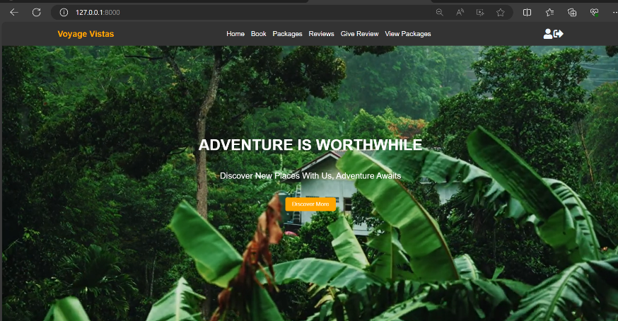At Voyage Vista, we believe that travel should be seamless, enjoyable, and tailored to your unique preferences. Our cutting-edge travel management website is designed to simplify every aspect of your journey, whether you're a globetrotter exploring new horizons or a business professional coordinating trips with precision.

# MODULES:

## USER SIDE:

### BOOK NOW:

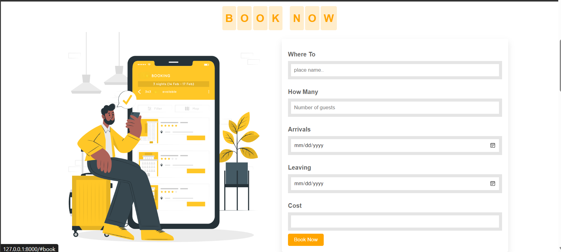

### PACKAGES:

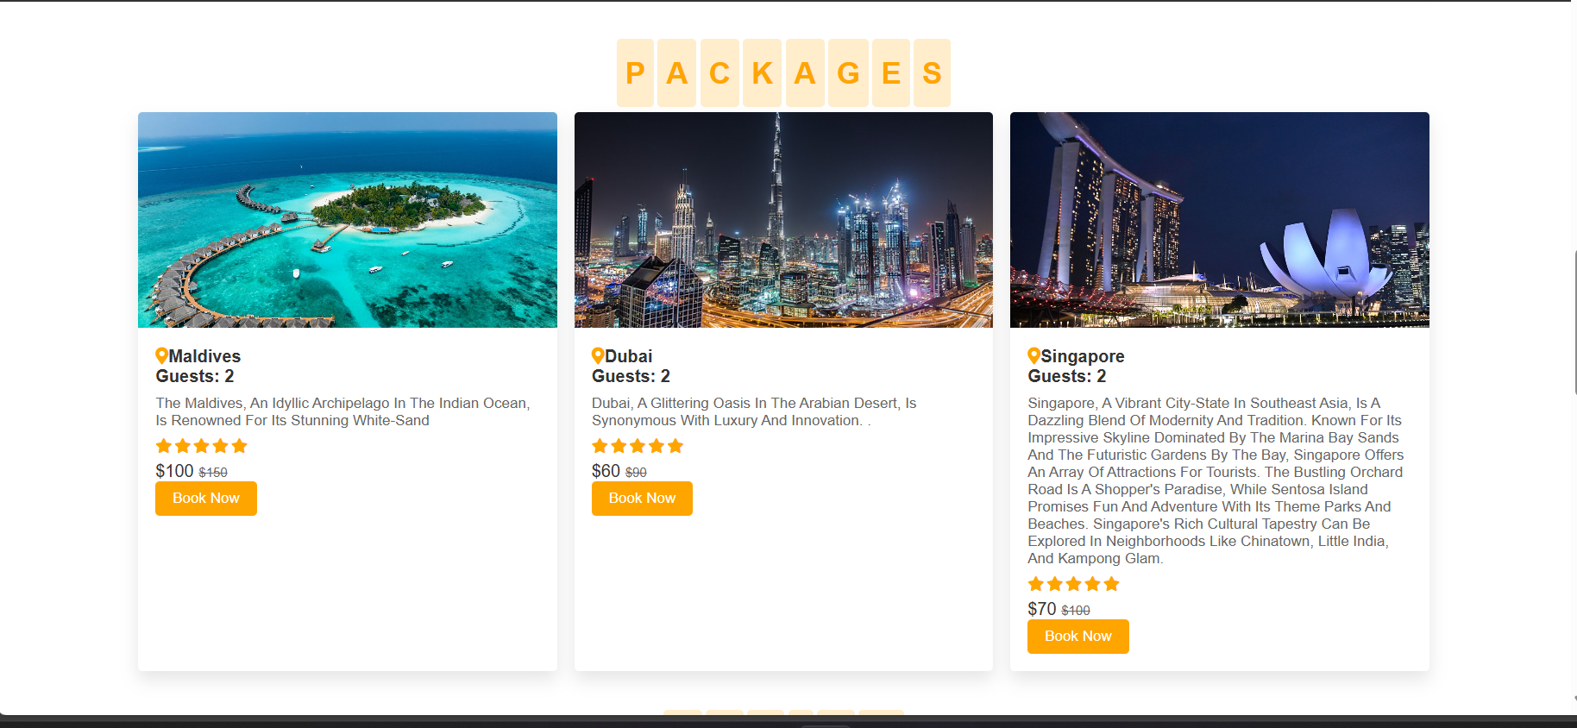

### REVIEWS:

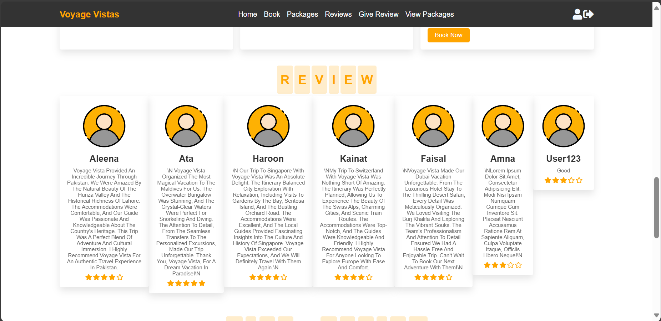

### GIVE REVIEWS:

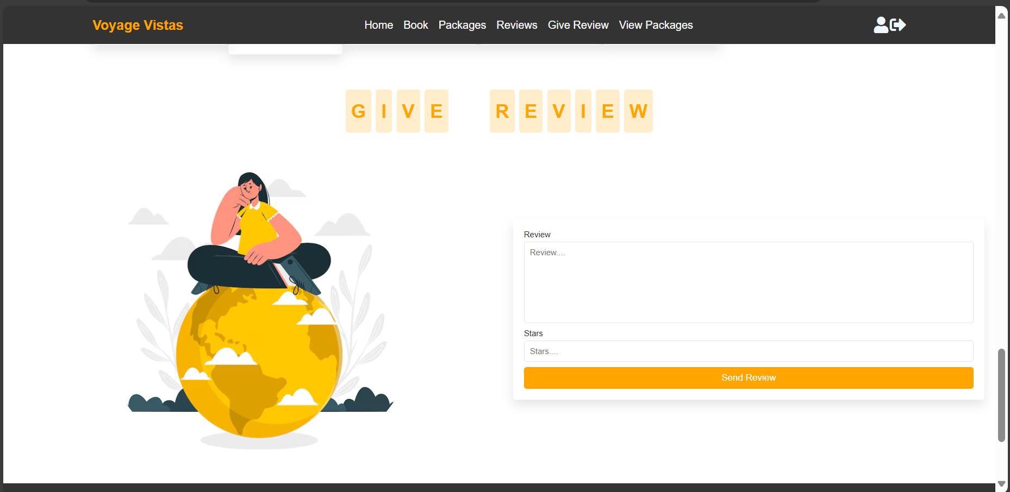

### PAKACKAGE ORDER COMPLETE:

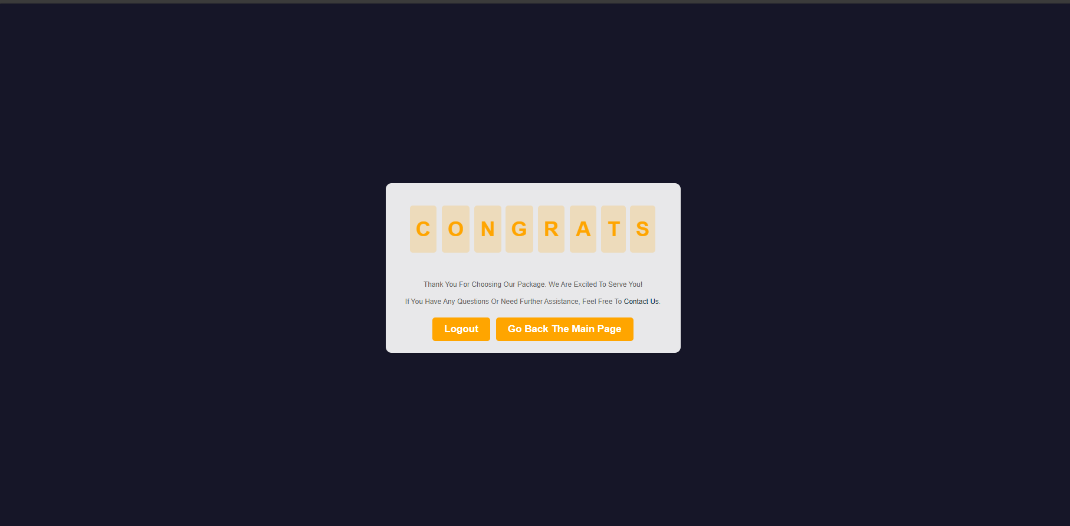

### USER PACKAGES DETAIL:

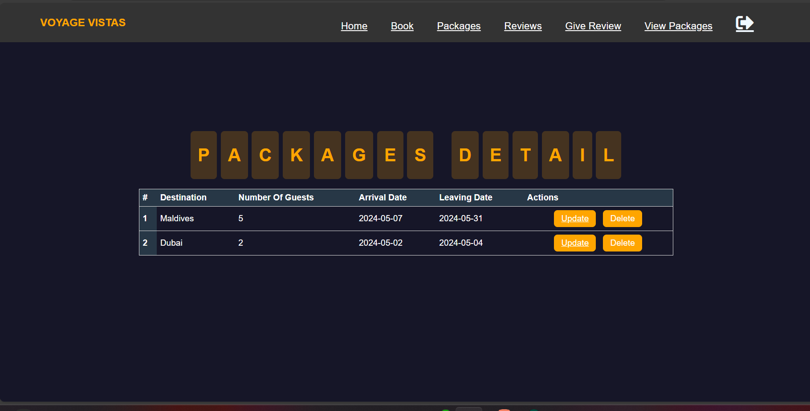

### A screenshot of a computer Description automatically generatedUPDATE USER PACAKGE:

### UPADTE USER PROFILE:

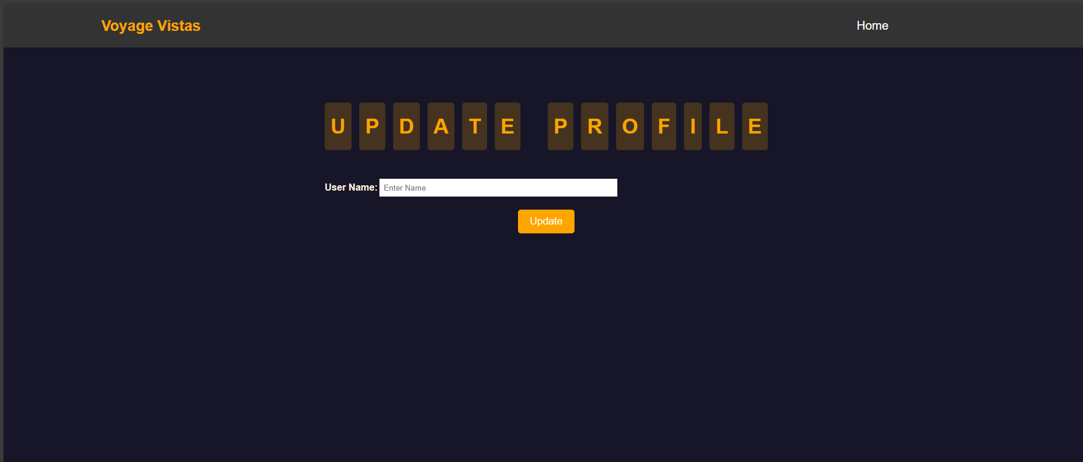

## ADMIN SIDE:

### ADMIN DASHBOARD:

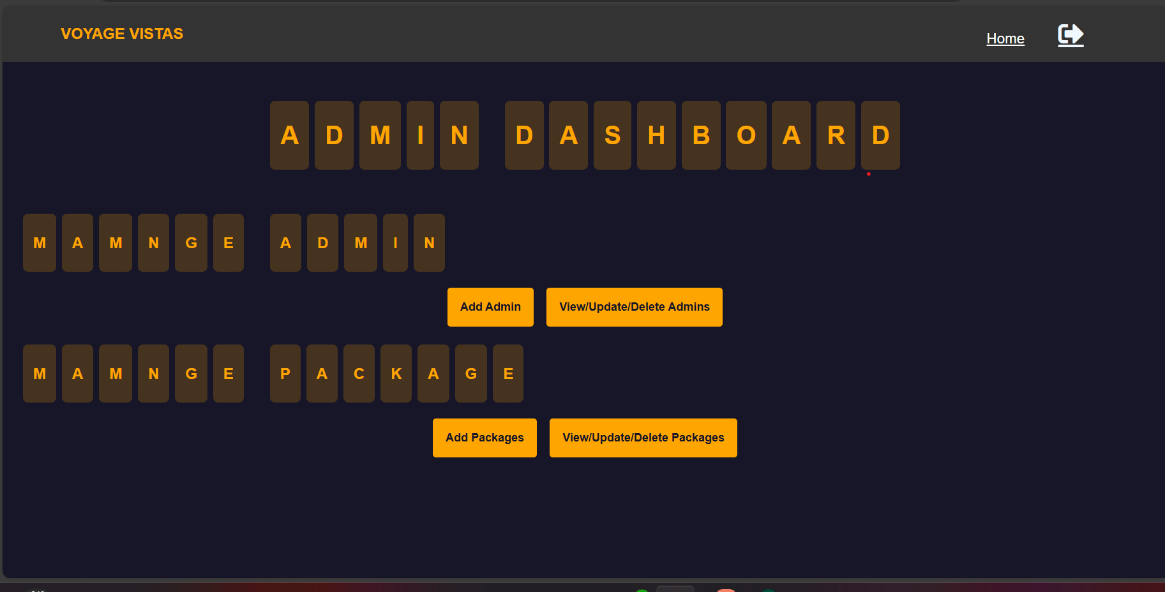

### ADD ANOTHER ADMIN:

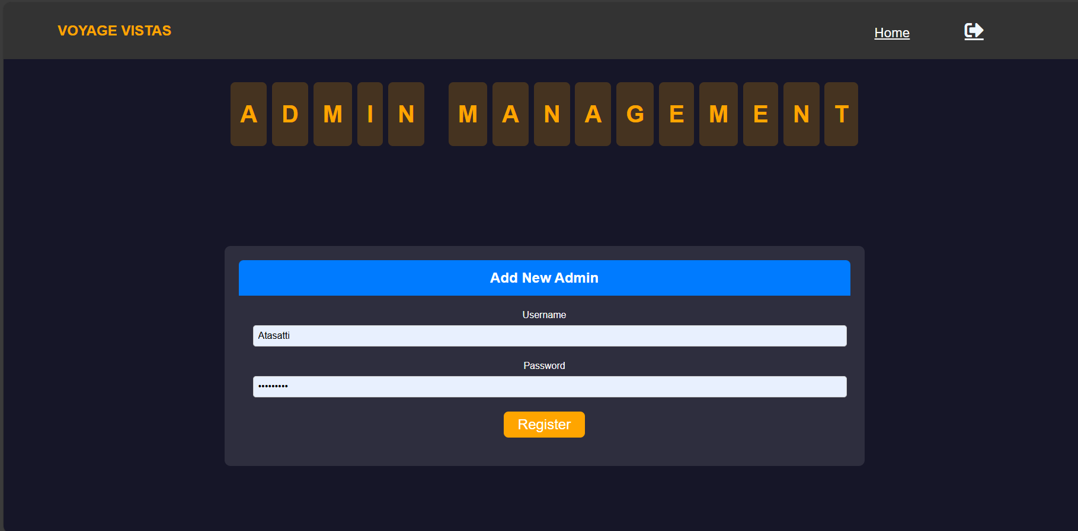

### UPDATE ADMINS:

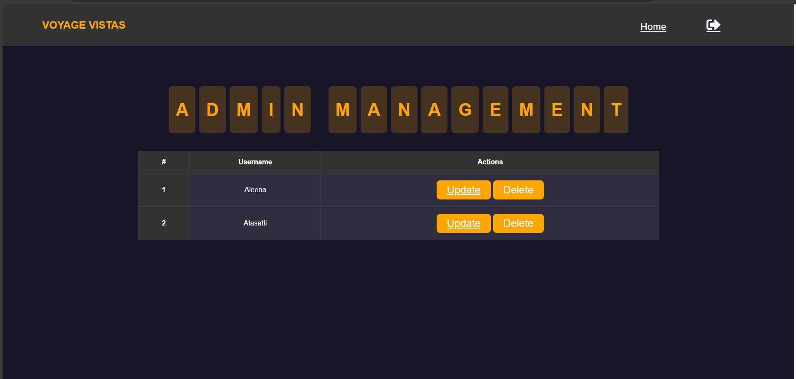

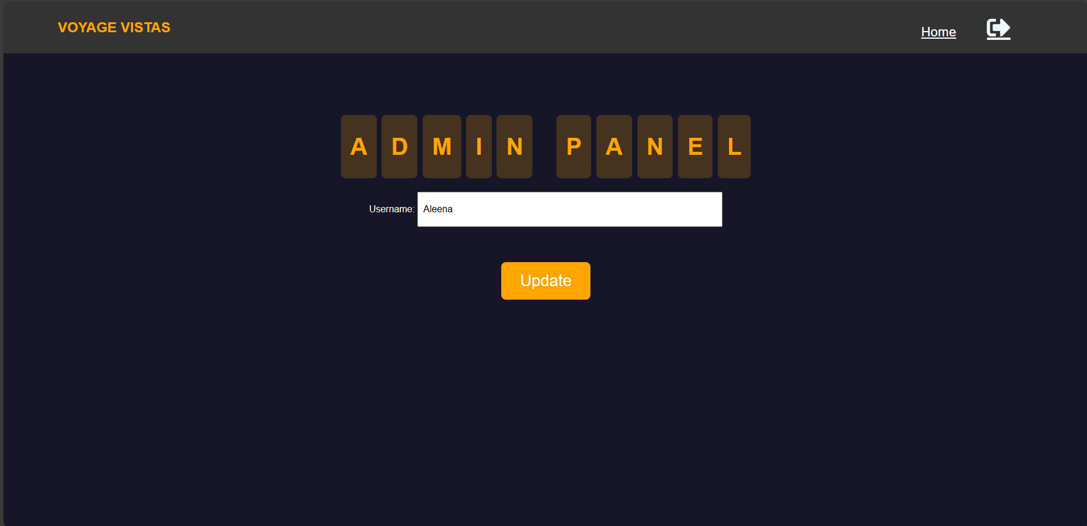

### ADMIN PACKAGES MANAGMENT:

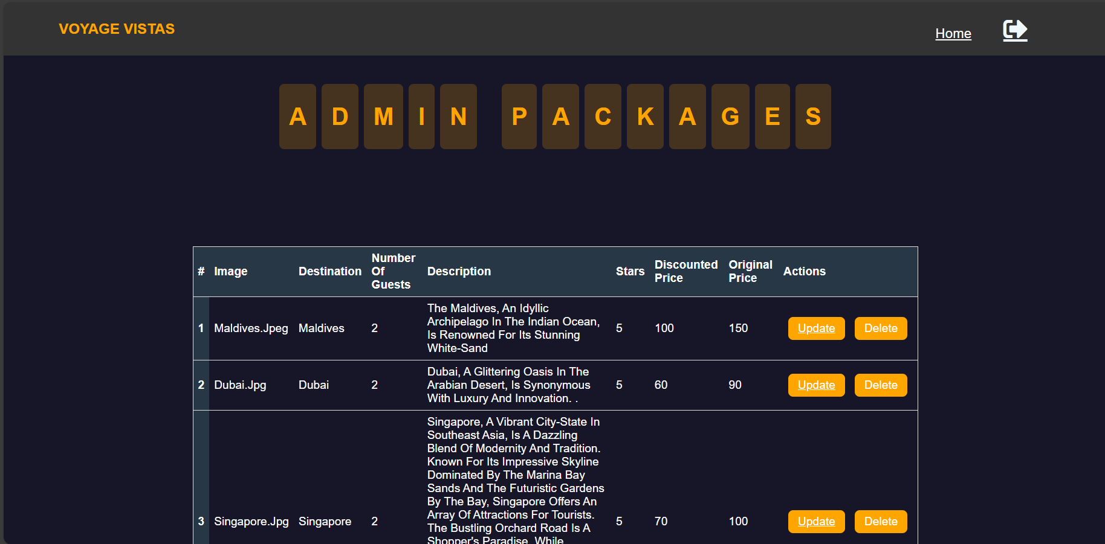

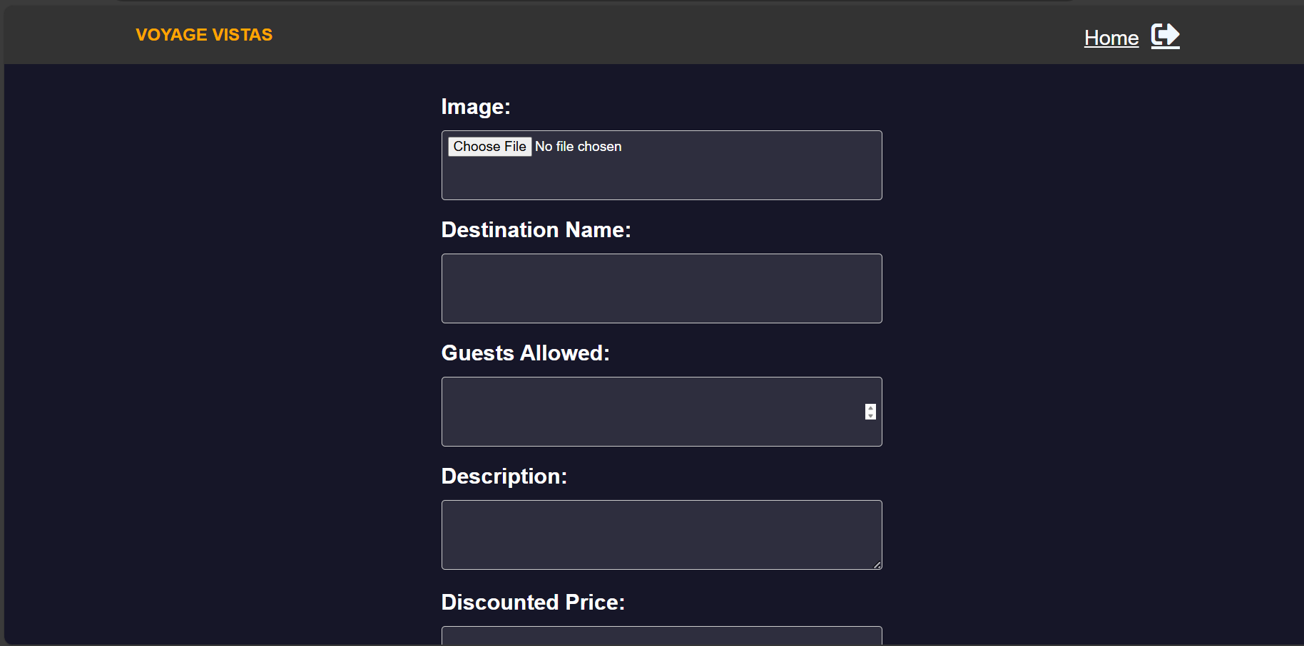

# PURPOSE:

* **Personalized Itineraries**: Create, manage, and customize your travel plans with ease.
* **Comprehensive Travel Resources**: Access a vast database of destinations, accommodations, and activities.
* **Real-time Updates**: Stay informed with the latest travel advisories, weather updates, and itinerary changes.

INTERFACE:

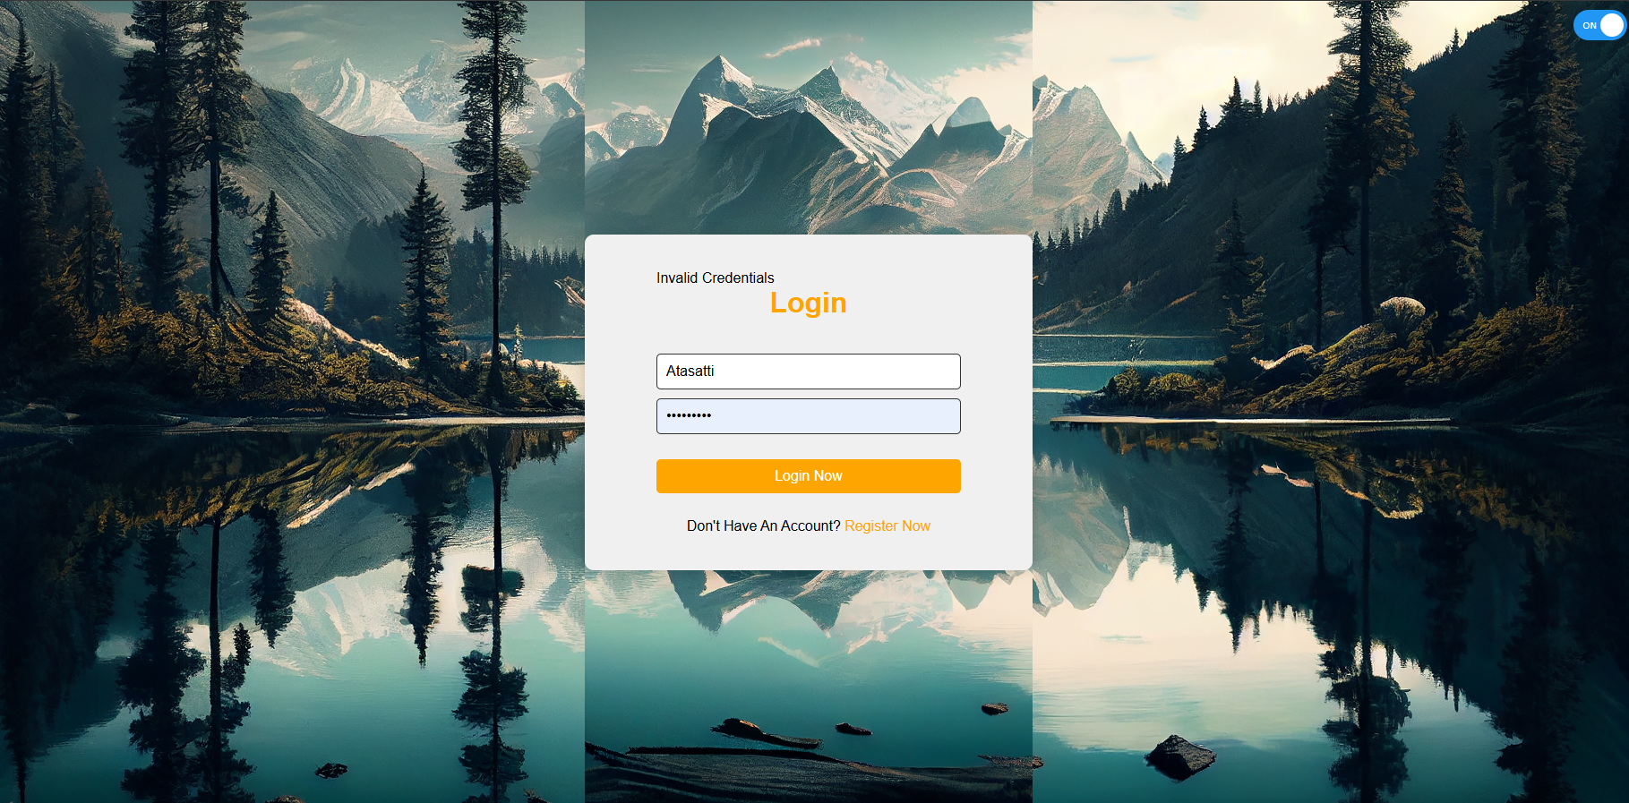

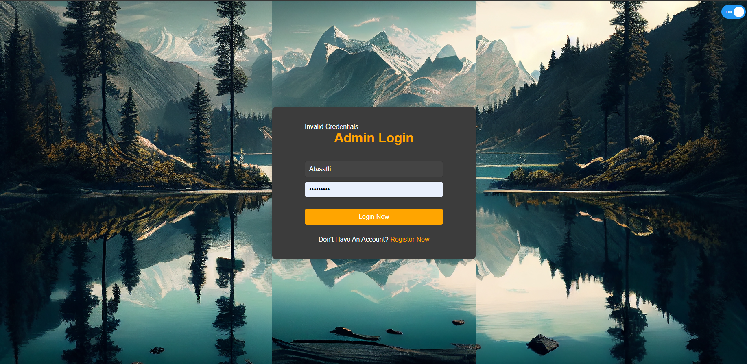

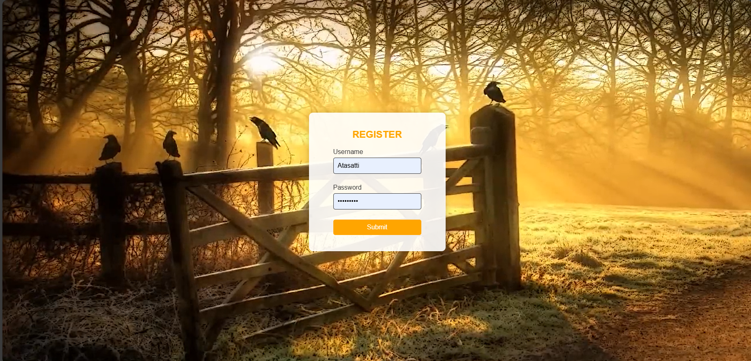

# IMPLEMENTATIONS:

## FRONTEND:

**Frontend: HTML, CSS, JavaScript**

1. **HTML (Hypertext Markup Language)**
   * **Purpose**: HTML forms the backbone of our frontend, providing the structure and content of the web pages.
   * **Functionality**: It includes various elements like headers, paragraphs, forms, buttons, and more to build a comprehensive user interface for travel management.
2. **CSS (Cascading Style Sheets)**
   * **Purpose**: CSS is used to style the HTML elements, making the interface visually appealing.
   * **Functionality**: It controls layout, colors, fonts, and overall look and feel of the website. For Voyage Vista, CSS ensures a consistent and attractive design across different devices.
3. **JavaScript**
   * **Purpose**: JavaScript adds interactivity and dynamic functionality to the website.
   * **Functionality**: It handles client-side logic, such as form validation, real-time updates, interactive maps, and dynamic content loading, enhancing the user experience.

## BACKEND:

1. **Python**
   * **Purpose**: Python is the programming language used for server-side development.
   * **Functionality**: It provides the core logic for the application, handling data processing, business rules, and integration with external services.
2. **FastAPI**
   * **Purpose**: FastAPI is a modern, fast (high-performance), web framework for building APIs with Python 3.7+.
   * **Functionality**:
     + **Efficient API Development**: FastAPI allows for the quick development of RESTful APIs, which are essential for handling CRUD operations for both admin and user functionalities.
     + **Asynchronous Support**: It supports asynchronous programming, which helps in handling multiple requests efficiently, leading to better performance and scalability.
     + **Automatic Documentation**: FastAPI automatically generates interactive API documentation (Swagger UI), making it easier for developers to test and understand the API endpoints.

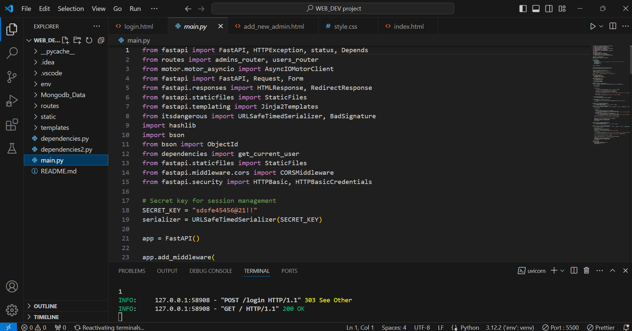

## DATABASE:

**MongoDB**

* **Purpose**: MongoDB is a NoSQL database that stores data in flexible, JSON-like documents.

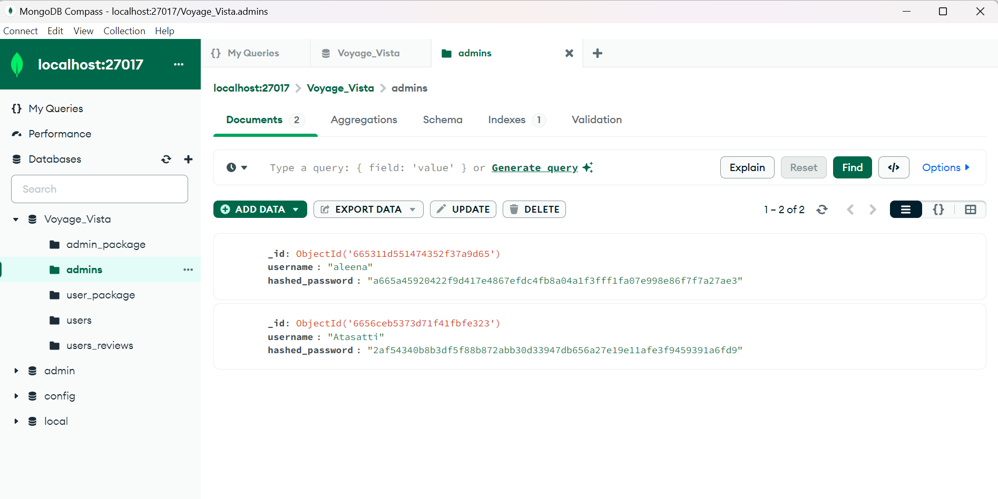

# CONCLUSION:

Voyage Vista is a state-of-the-art travel management platform designed to cater to the diverse needs of modern travelers. By leveraging a robust and efficient technology stack, we ensure that every aspect of your travel experience is seamless, personalized, and secure.

Our frontend, crafted with HTML, CSS, and JavaScript, delivers a user-friendly and visually appealing interface, making it easy to navigate and interact with the platform. The backend, powered by Python and FastAPI, provides a high-performance and scalable API infrastructure, capable of handling complex operations and real-time updates with ease. MongoDB, our database of choice, offers the flexibility and performance required to manage extensive travel data securely and efficiently.

Whether you are an admin managing multiple users or a traveler planning your next adventure, Voyage Vista is designed to meet your needs with comprehensive CRUD operations, personalized itineraries, and real-time updates. With Voyage Vista, you can embark on your journeys with confidence, knowing that every detail is meticulously managed and supported by advanced technology.